**Answer Sheet - SQL**

Name : **NOORAIN NAIZ**

Phone No. : 91-8180941144

Email : noorainkhatik777@gmail.com

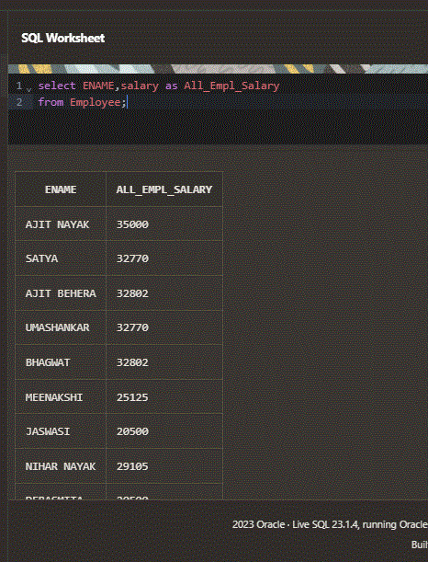

**Major Question 1**

1. List the salary of all the employees.

Insert Image

select ENAME,salary as All_Empl_Salary

from Employee;

1. Display the names of all employees with any “A” at any place of the name.

Insert Image –

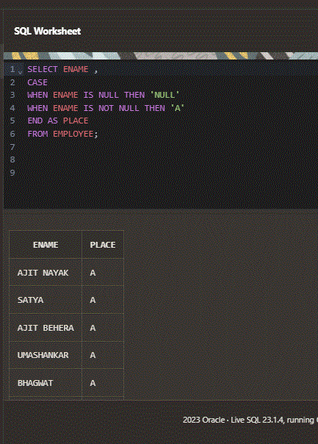SELECT ENAME ,

CASE

WHEN ENAME IS NULL THEN 'NULL'

WHEN ENAME IS NOT NULL THEN 'A'

END AS PLACE

FROM EMPLOYEE;

1. Show all employees who were hired in the first half of the month (Before the 16th of the month).

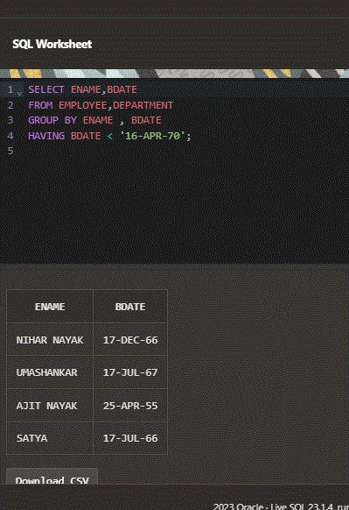

Insert Image -

SELECT ENAME,BDATE

FROM EMPLOYEE,DEPARTMENT

GROUP BY ENAME , BDATE

HAVING BDATE < '16-APR-70';

1. Display the name of all female employees.

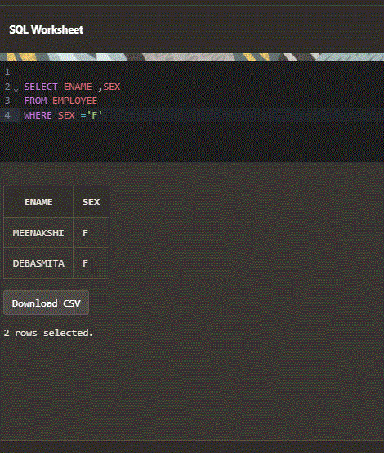Insert Image -

ELECT ENAME,SEX

FROM EMPLOYEE

WHERE SEX='F'

1. Display the employee who is paid most in the company.

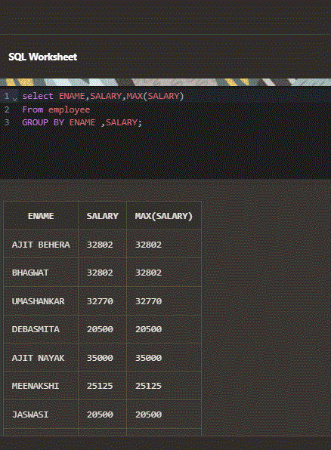

Insert Image –

SELECT ENAME,SALARY,MAX(SALARY)

FROM EMPLOYEE

GROUP BY ENAME,SALARY;

**Major Question 2**

1. Display employee name, address, department no and department name.

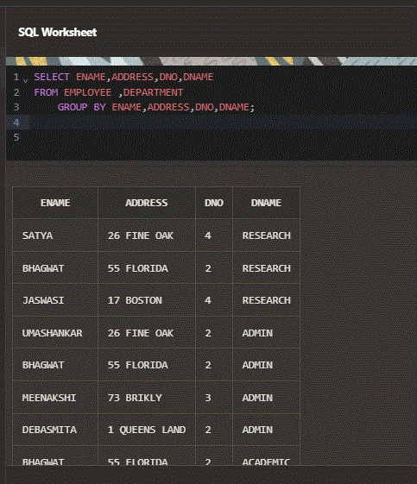

Insert Image –

SELECT ENAME,ADDRESS,DNO,DNAME

FROM EMPLOYEE ,DEPARTMENT

GROUP BY ENAME,ADDRESS,DNO,DNAME;

1. Display all the employees who are *not in* ACADEMIC department

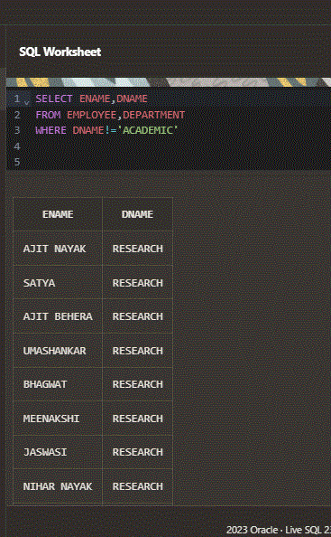

Insert Image –

SELECT ENAME,DNAME

FROM EMPLOYEE,DEPARTMENT

WHERE DNAME!='ACADEMIC'

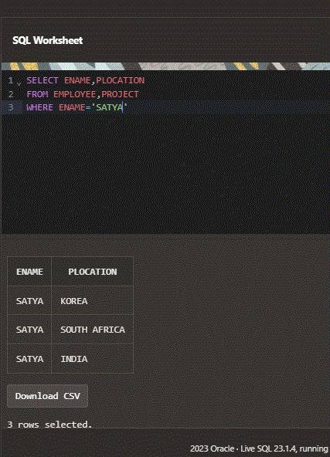

1. Display SATYAS’ project location.

Insert Image - SELECT ENAME,PLOCATION

FROM EMPLOYEE,PROJECT

WHERE ENAME='SATYA'

1. Find the total working hours of *each* female employee.

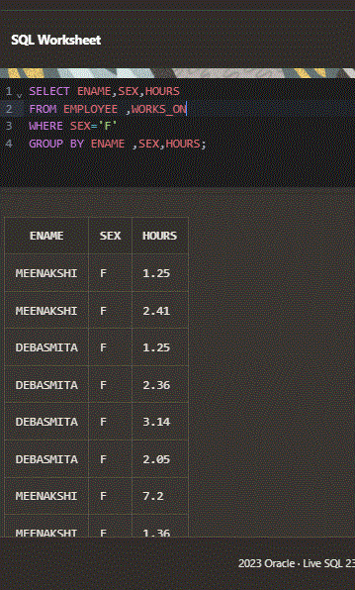

Insert Image -

SELECT ENAME,SEX,HOURS

FROM EMPLOYEE ,WORKS_ON

WHERE SEX='F'

GROUP BY ENAME, SEX, HOURS;

1. 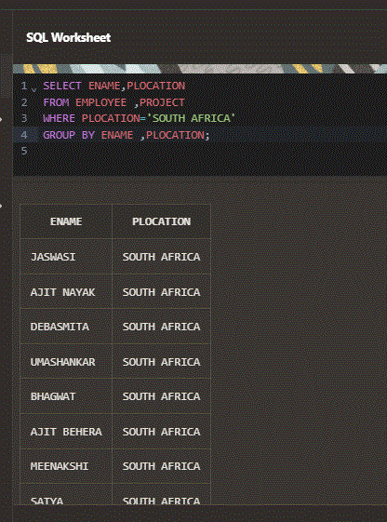Display the details of the people whose projects are located at SOUTH AFRICA.

Insert Image -

SELECT ENAME ,PLOCATION

FROM EMPLOYEE ,PROJECT

WHERE PLOCATION ='SOUTH AFRICA'

GROUP BY ENAME, PLOCATION ;